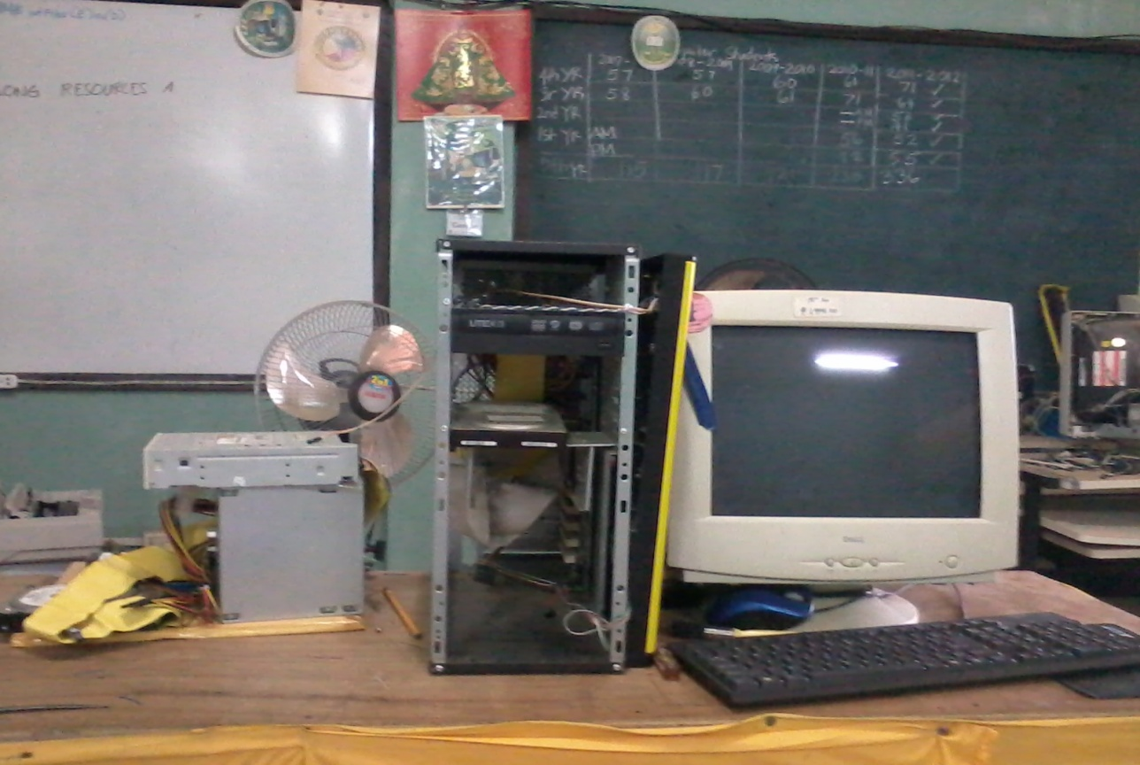

PC that needed repair
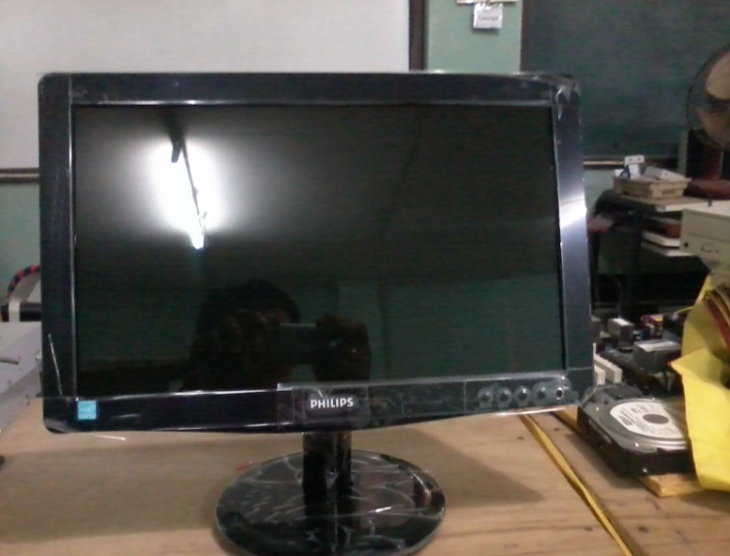
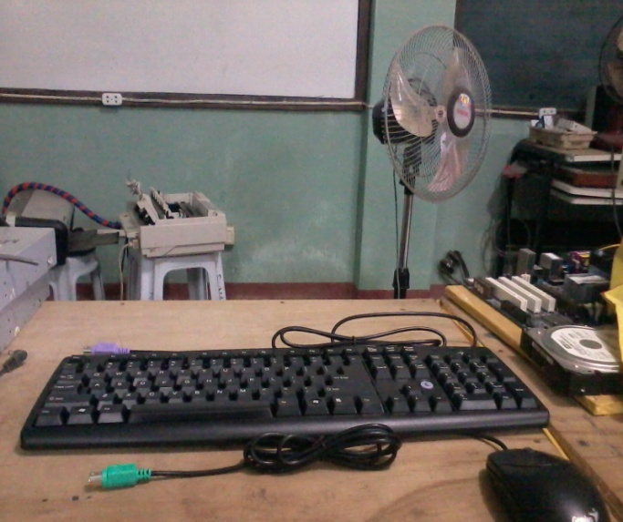

Philips 15.6” LED Monitor Keyboard and Mouse

Prepared by:
GEORGE P. LUMAYAG
ICT Coordinator
www.georgelumayag.com

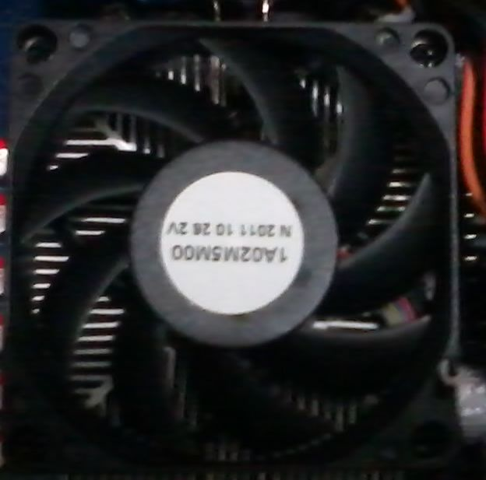
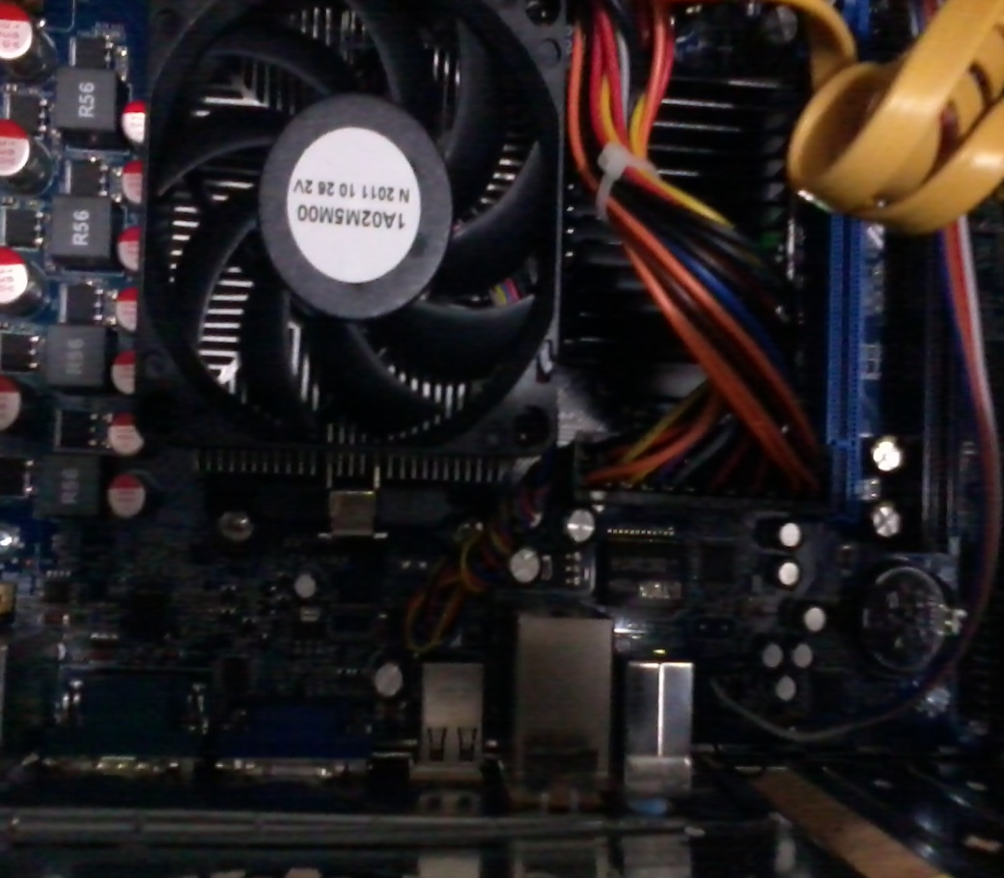

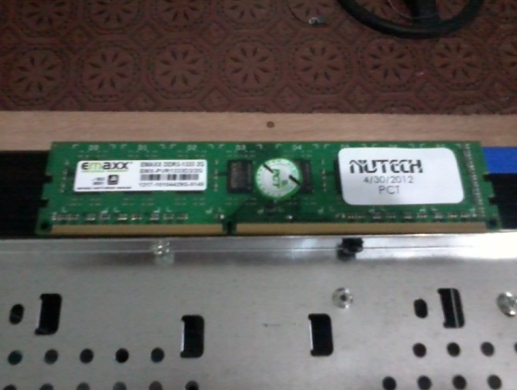
AND SEMPRON 145 fixed

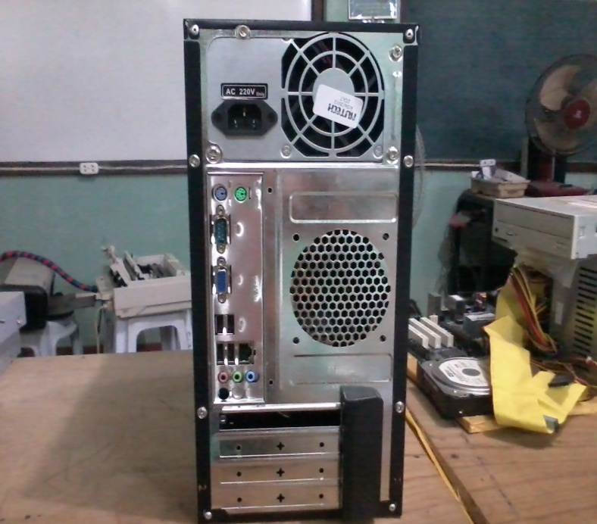
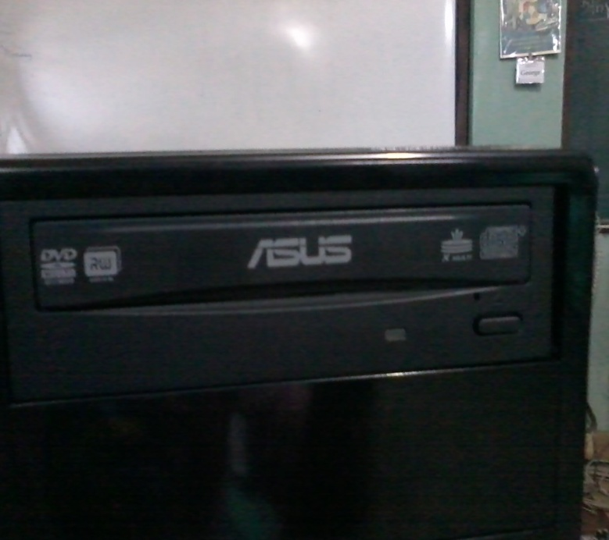
2GB DDR3 RAM BIOSTAR N6853B MOTHERBOARD

ASUS DVD-RW ATX CASING

Prepared by:
GEORGE P. LUMAYAG
ICT Coordinator
www.georgelumayag.com

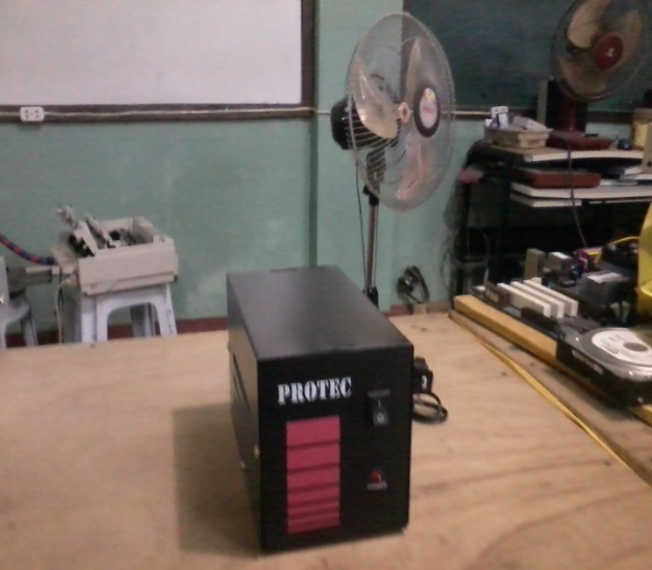
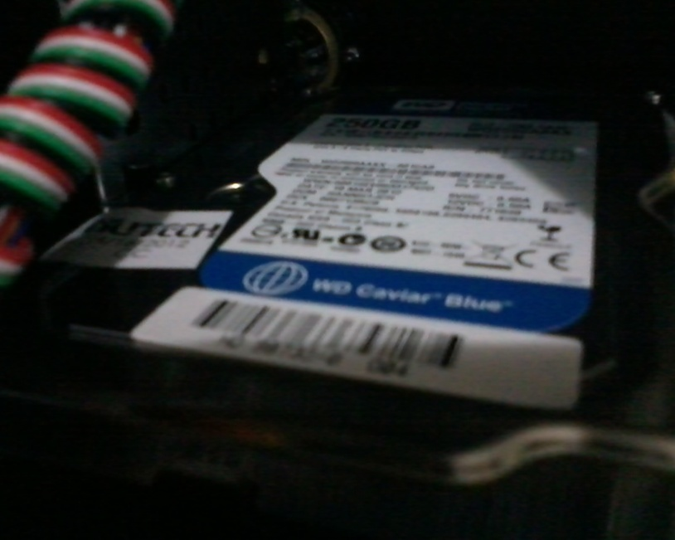

WD SATA 250 GB HDD PROTEC AVR

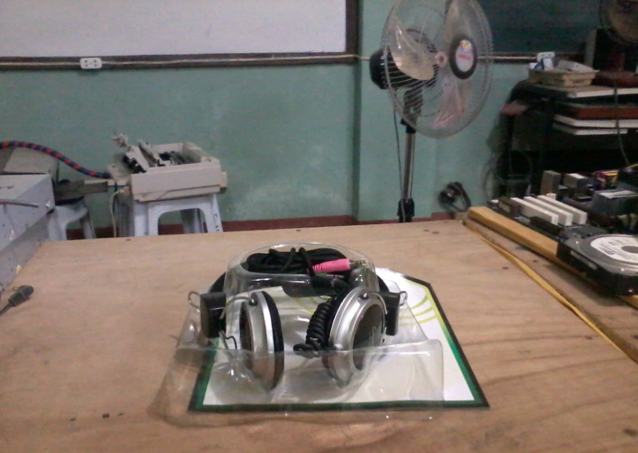
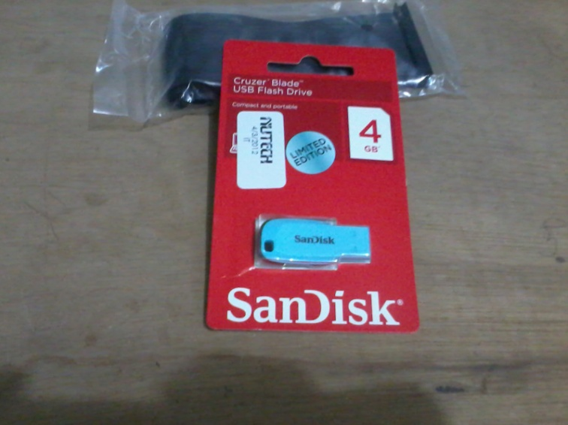

HEADSET SCANDISK 4GB USB

Prepared by:
GEORGE P. LUMAYAG
ICT Coordinator
www.georgelumayag.com

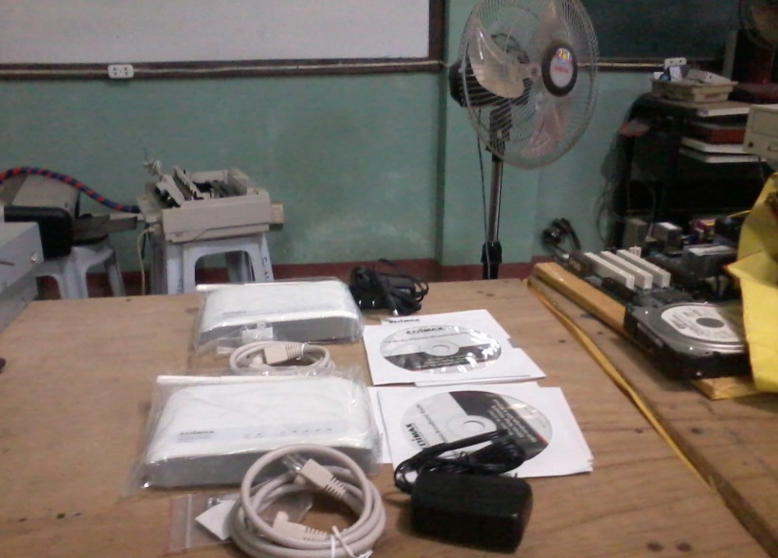
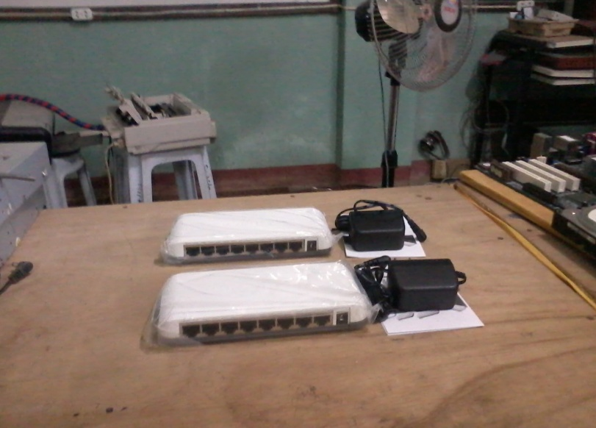

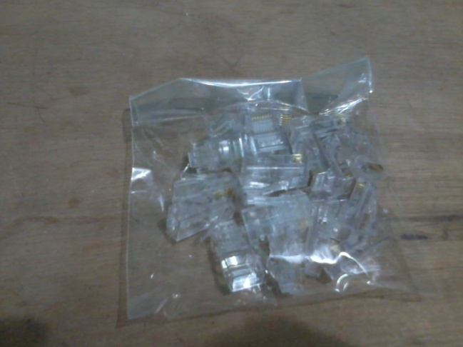
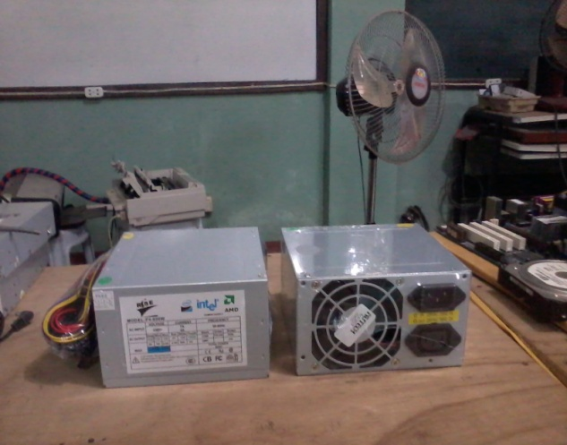
EDIMAX 8 PORT-SWITCH EDIMAX 3R-6228NS WIFI ROUTER

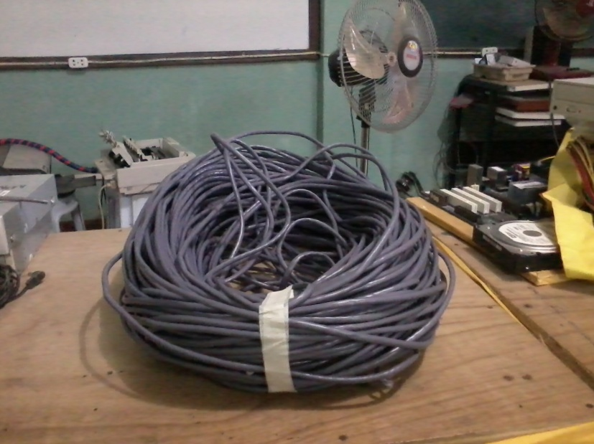
RJ45 CONNECTOR POWER SUPPLY 600W ATX

UTP CABLE

Prepared by:
GEORGE P. LUMAYAG
ICT Coordinator
www.georgelumayag.com

